Thursday, August 11, 2022
2:00 – 3:30 pm

Adults and Teens:
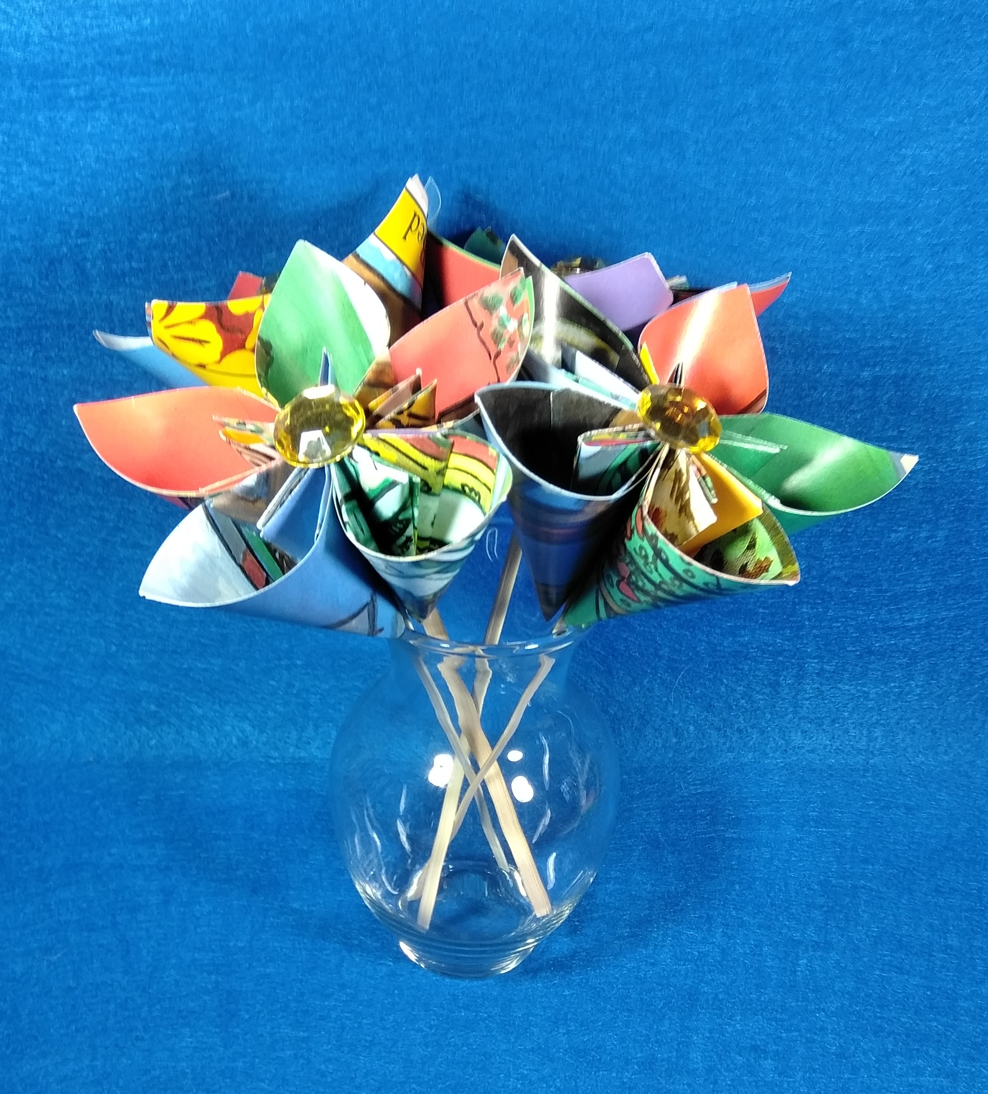

Learn how to make an origami “kusudama” flower. These paper flowers are decorative and charming. This is an easy paper folding project – beginners are welcome! All supplies will be provided.

Registration required.

